1. Select Your Operating System (OS): Choose an operating system that best suits your preferences and project requirements. Download and Install Windows 11.

Already running on windows 11.

1. Install a Text Editor or Integrated Development Environment (IDE): Select and install a text editor or IDE suitable for your programming languages and workflow. Download and Install Visual Studio Code.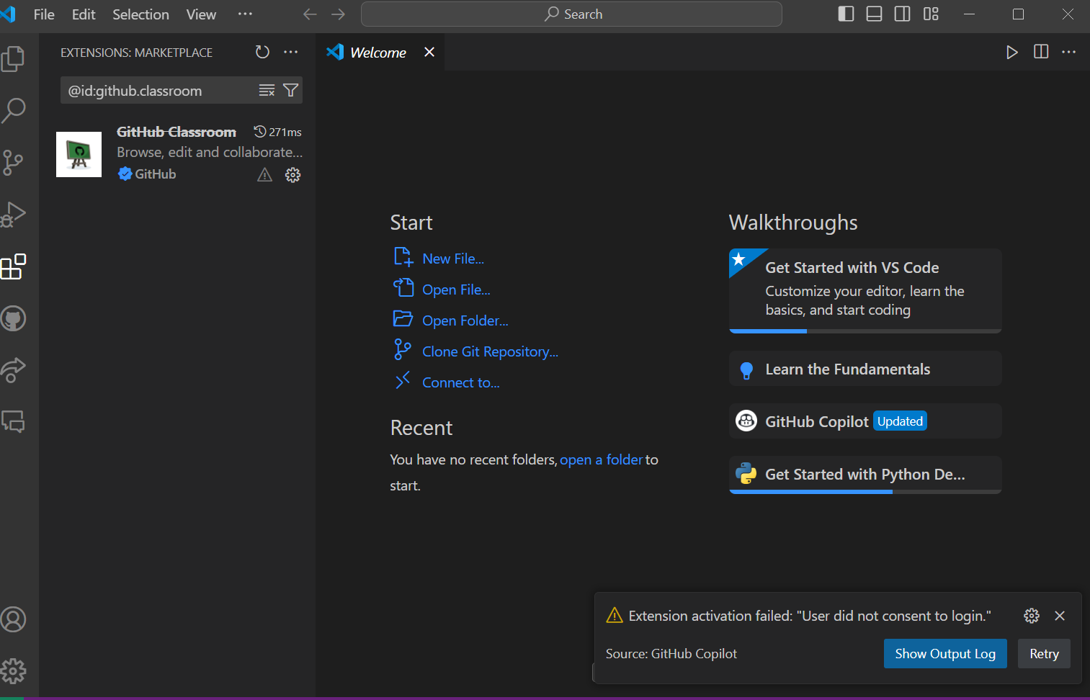
2. Set Up Version Control System: Install Git and configure it on your local machine. Create a GitHub account for hosting your repositories. Initialize a Git repository for your project and make your first commit.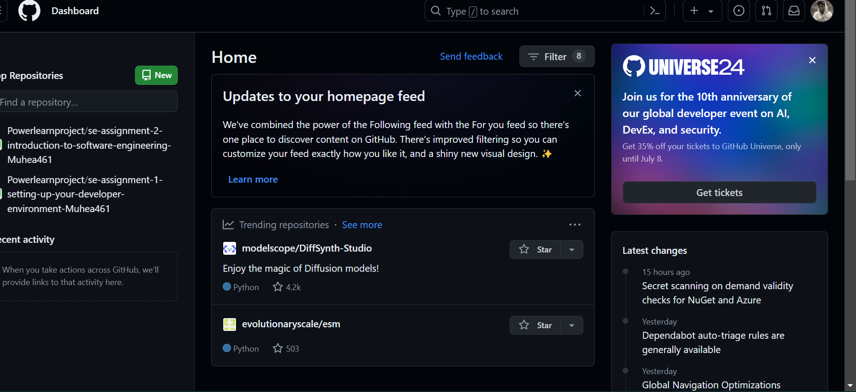
3. Install Necessary Programming Languages and Runtimes: Instal Python from http://wwww.python.org programming language required for your project and install their respective compilers, interpreters, or runtimes. Ensure you have the necessary tools to build and execute your code.

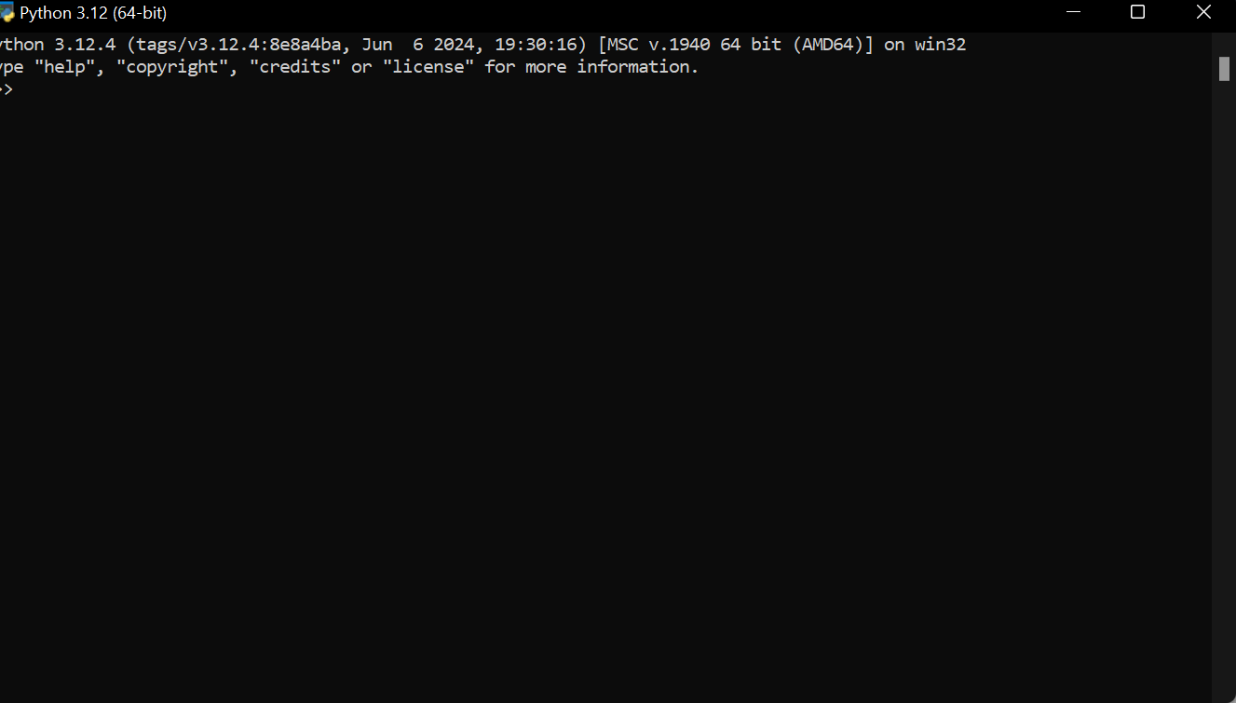

1. Configure a Database (MySQL): Download and install MySQL database.
2. 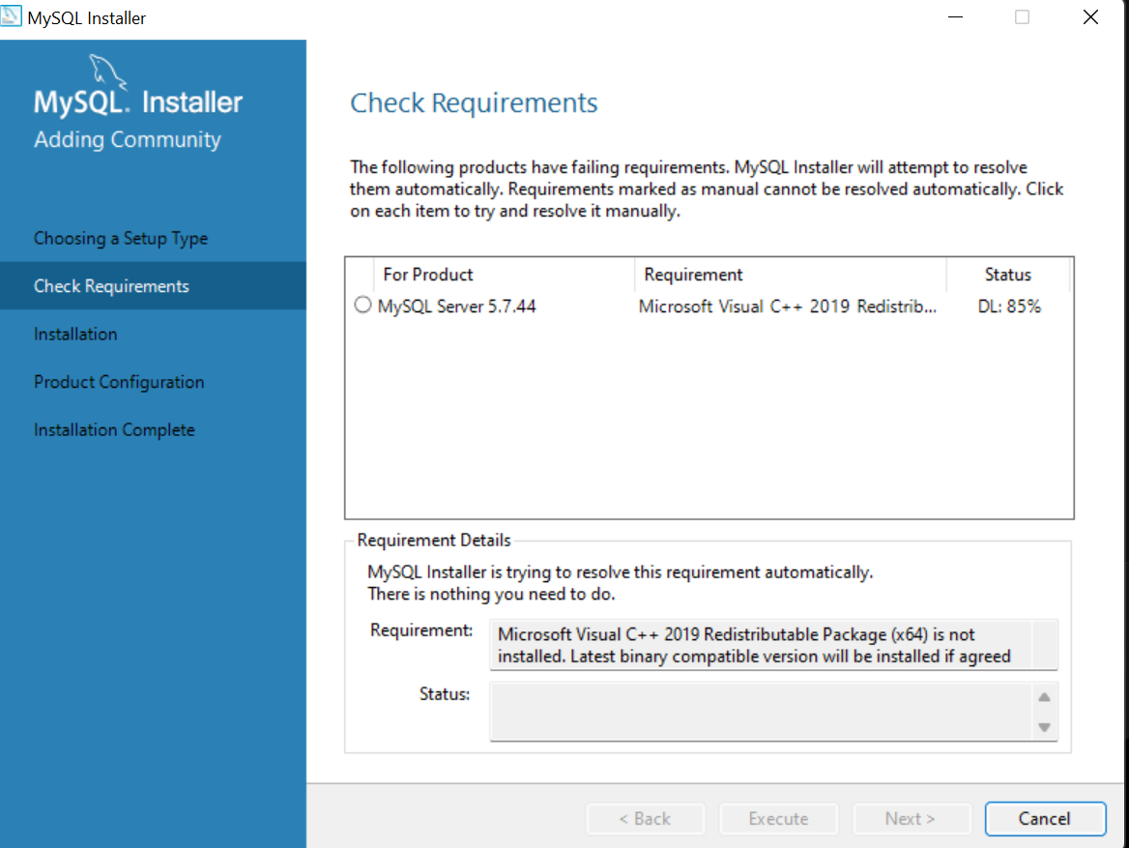

dd